**NAMA: ANDI DWI SAPUTRO**

**Hackerrank username: andiads06 (DAY 3)**

1. **Soal Medium**
2. **Java MD5**

**Link:** <https://www.hackerrank.com/challenges/java-md5/problem>

Accepted Answer:

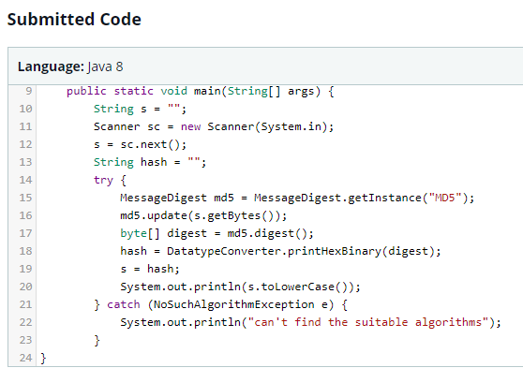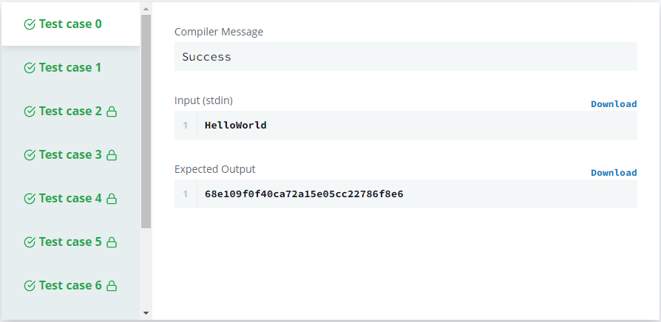

**Soal Easy**

1. **Java 1D Array**

**Link:** <https://www.hackerrank.com/challenges/java-1d-array-introduction/problem>

Accepted Answer:

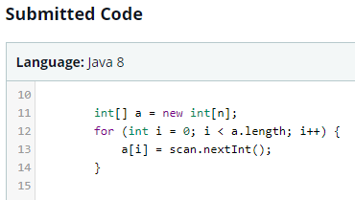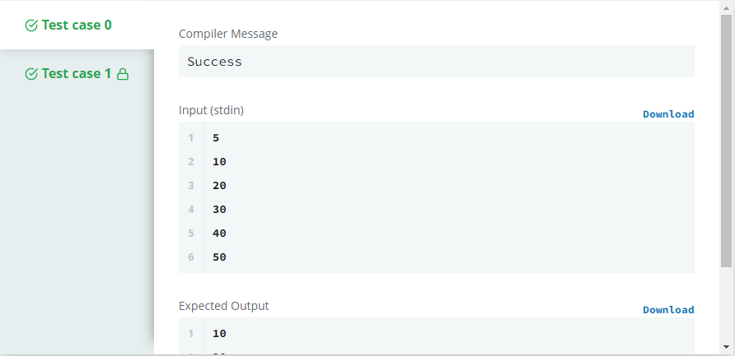

1. **Java Primality Test**

**Link:** <https://www.hackerrank.com/challenges/java-primality-test/problem>

Accepted Answer:

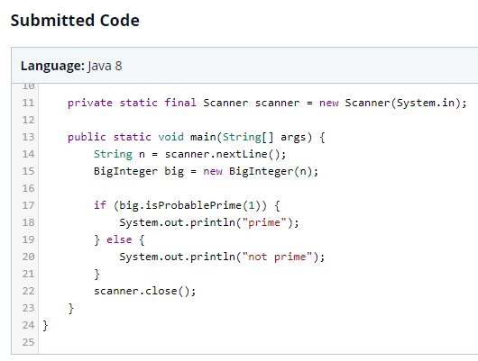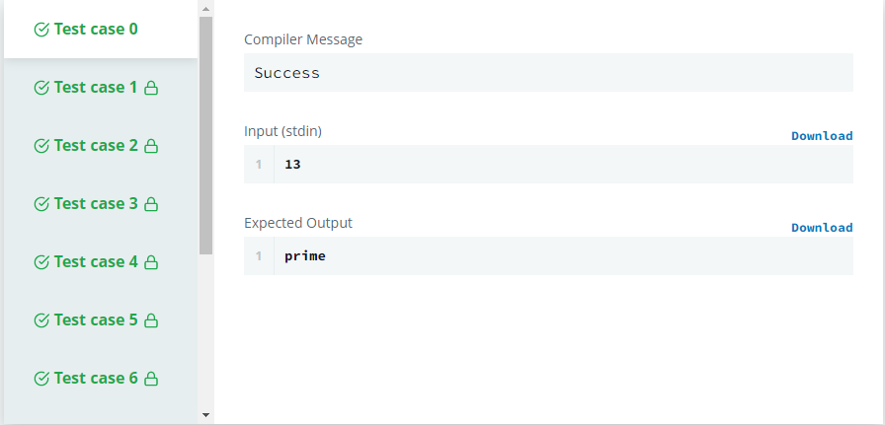

1. **Java Map (Phonebook)**

**Link:** <https://www.hackerrank.com/challenges/phone-book/problem>

Accepted Answer:

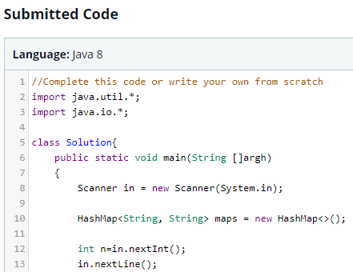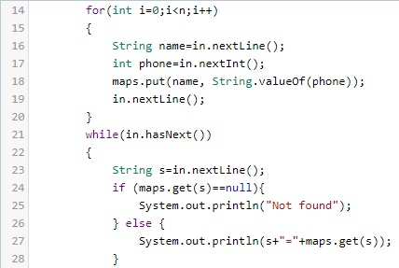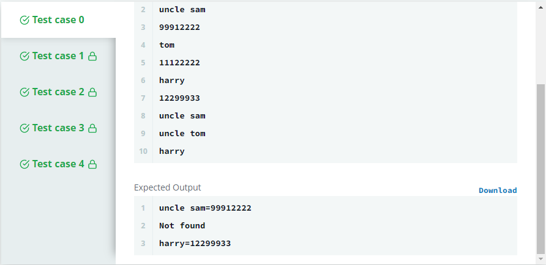

1. **Java Sort**

**Link:** <https://www.hackerrank.com/challenges/java-sort/problem>

Accepted Answer:

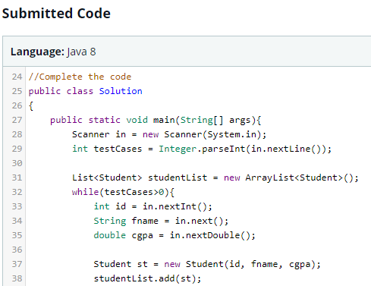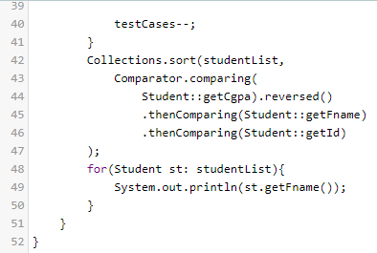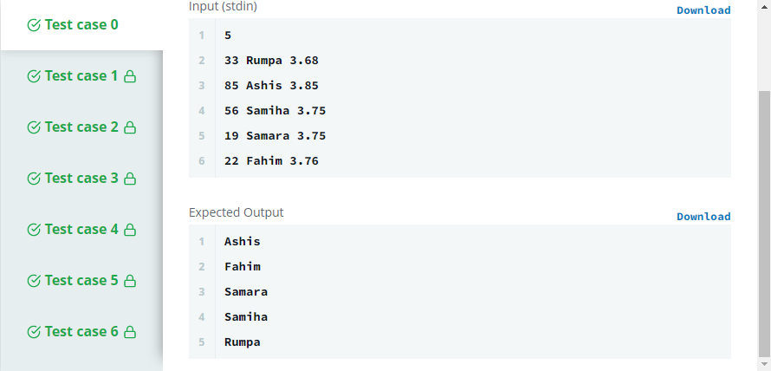

1. **Java Exception-Handling (Try Catch)**

**Link:** <https://www.hackerrank.com/challenges/java-exception-handling-try-catch/problem>Q:

Accepted Answer:

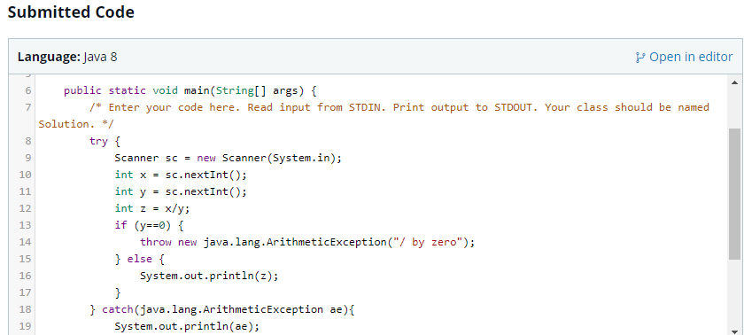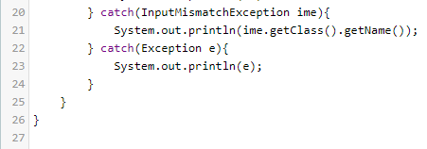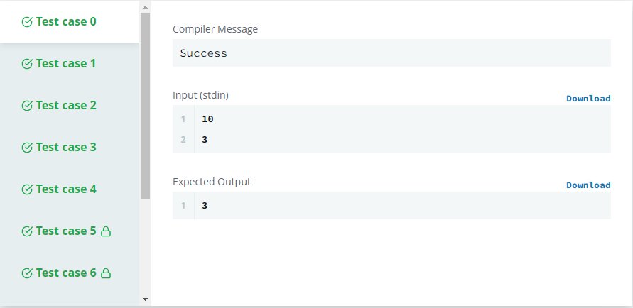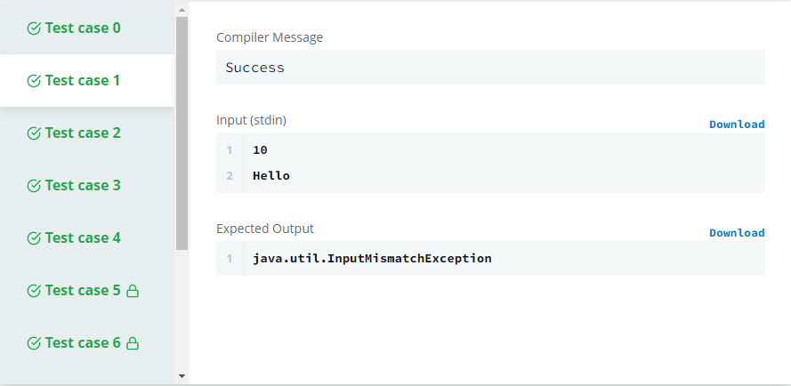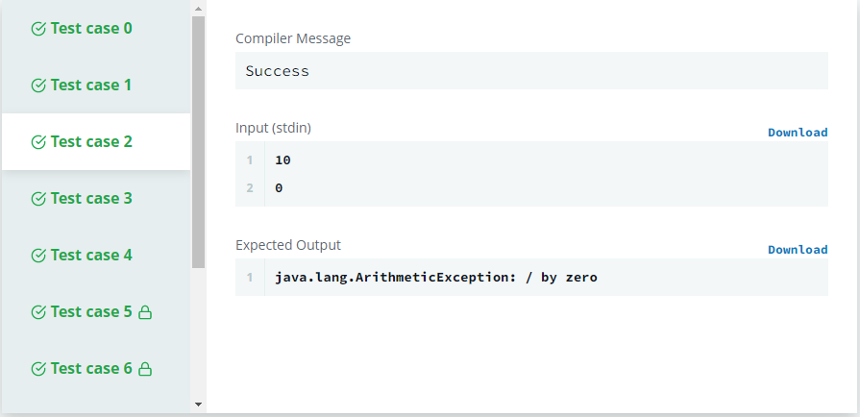

1. **Java Reflection**

**Link:** <https://www.hackerrank.com/challenges/java-reflection-attributes/problem>Q:

**Accepted Answer:**

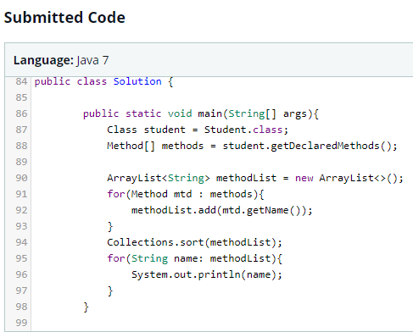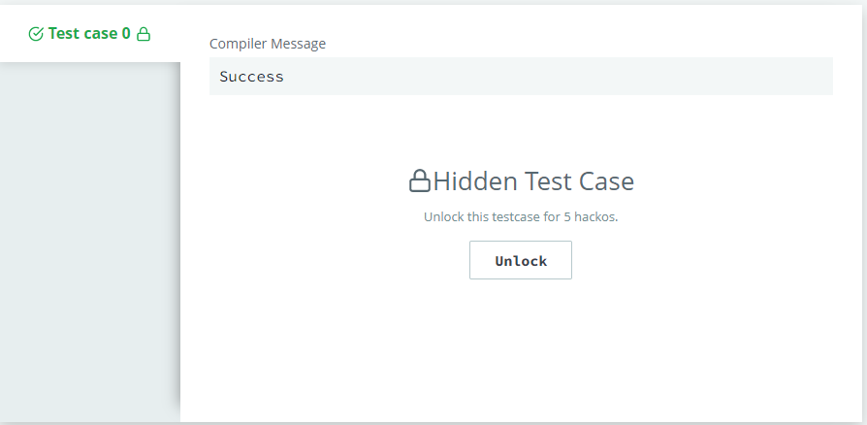

1. **Java Method Overriding**

**Link:** <https://www.hackerrank.com/challenges/java-method-overriding/problem>

Accepted Answer:

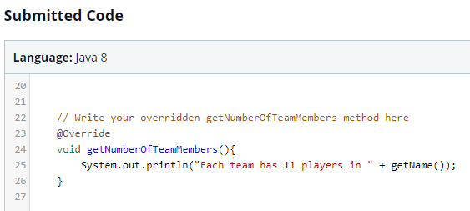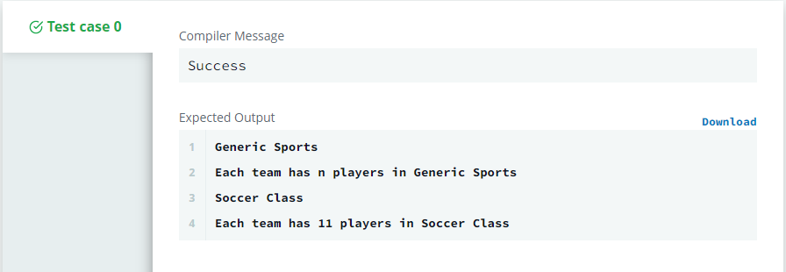

1. **Java Generics**

**Link:** <https://www.hackerrank.com/challenges/java-generics/problem>

**Accepted Answer:**

